Mutual Fund Analytics Project

SQL ANALYSIS REPORT

Prepared By: Shravan Rajendra Bhandare
Technology Stack:
- Python
- SQLite
- Pandas
- SQL
Project:
Mutual Fund Analytics & Recommendation System

Date:
June 2026

Project Overview

Objective
The objective of this project is to analyze mutual fund performance, investor transactions, and fund characteristics using SQL and SQLite.
The project focuses on:
- Fund Performance Analysis
- Investor Behavior Analysis
- Risk Analysis
- Asset Under Management (AUM) Analysis
- Transaction Analytics
The insights generated through SQL queries will be used later in dashboards and fund recommendation systems.

Table Name | Description
dim_fund | Fund master data
fact_nav | Historical NAV data
fact_transactions | Investor transaction records
fact_performance | Fund performance metrics
fact_sip_inflows | SIP trend data

Table | Records
dim_fund | 40
fact_nav | 46,000
fact_transactions | 32,778
fact_performance | 40
fact_sip_inflows | 48

Query 1: Top 5 Funds by AUM
Business Objective
Identify the largest mutual funds based on Assets Under Management.
SQL Query:
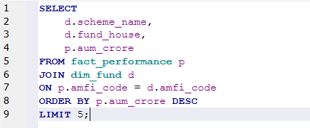
Output:
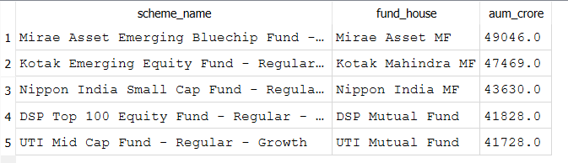

Key Insight:
The analysis shows the top five mutual funds managing the highest assets, indicating strong investor trust and market presence.

Query 2: Average NAV Per Month
Business Objective
Analyze monthly Net Asset Value (NAV) trends to understand fund growth patterns and market performance over time.
SQL Query
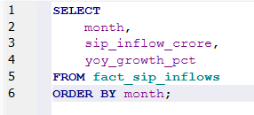
Output
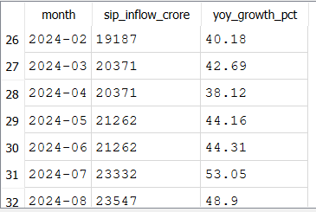
Key Insight
Monthly NAV trends help evaluate fund stability and long-term growth behavior across different market conditions.

Query 3: SIP YoY Growth
Business Objective
Measure the year-over-year growth of Systematic Investment Plan (SIP) inflows to assess investor participation and industry expansion.
SQL Query
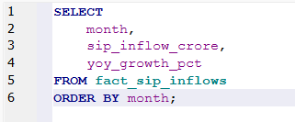
Output:
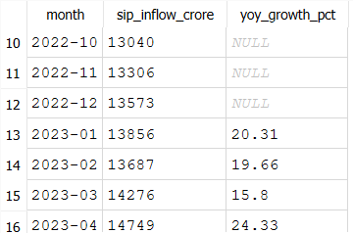

Key Insight
Consistent growth in SIP inflows indicates increasing retail investor awareness and confidence in mutual fund investments.

Query 4: Transactions by State
Business Objective
Identify geographic regions contributing the highest number of mutual fund transactions and investment amounts.
SQL Query
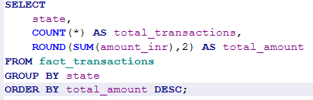
Output
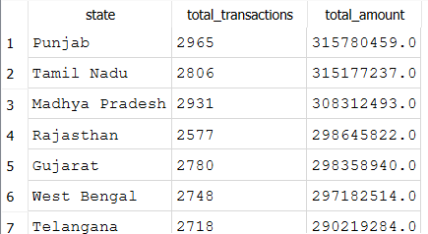

Key Insight
The analysis highlights states with stronger mutual fund adoption and higher investment activity.

Query 5: Funds with Expense Ratio Below 1%
Business Objective
Identify cost-efficient mutual funds that offer investment opportunities with lower management expenses.
SQL Query
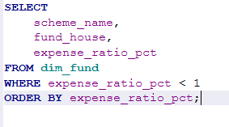
Output
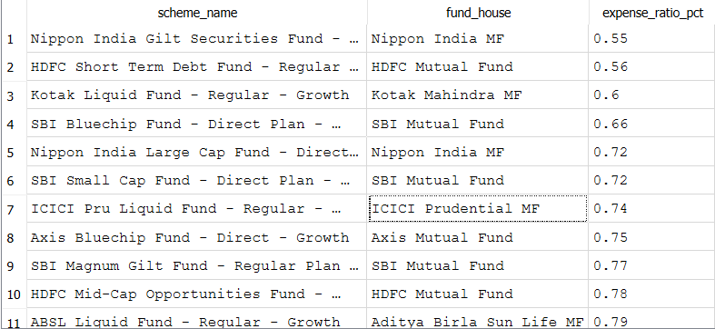

Key Insight
Funds with lower expense ratios can potentially improve long-term investor returns by reducing operating costs.

Query 6: Top 10 Funds by 5-Year Return
Business Objective
Identify mutual funds that have delivered the highest returns over a five-year investment horizon.
SQL Query
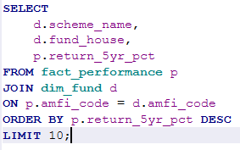
Output
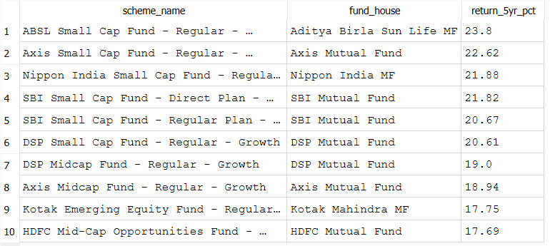

Key Insight
The results reveal consistently high-performing funds that have generated superior long-term returns for investors.

Query 7: Top 10 Funds by Sharpe Ratio
Business Objective
Evaluate funds based on risk-adjusted performance using the Sharpe Ratio metric.
SQL Query
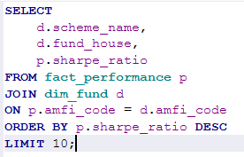
Output
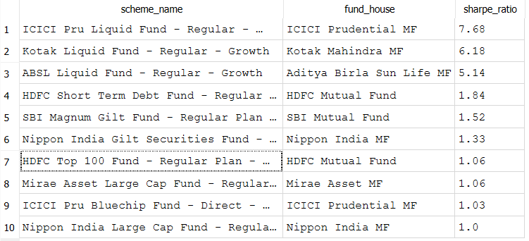

Key Insight
A higher Sharpe Ratio indicates that a fund has generated better returns relative to the risk undertaken.

Query 8: Highest Rated Funds
Business Objective
Identify mutual funds with the highest ratings to evaluate quality and consistency of performance.
SQL Query
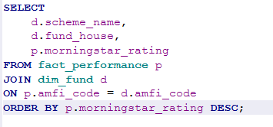
Output
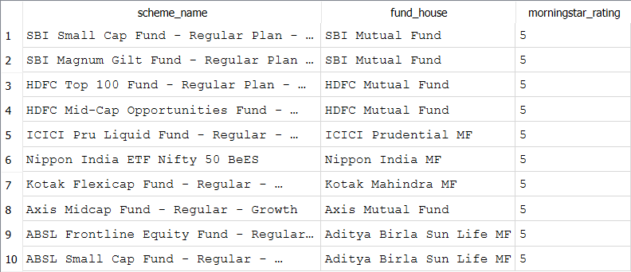

Key Insight
Highly rated funds generally demonstrate strong performance, effective management, and consistency over time.

Query 9: Investment by Gender
Business Objective
Analyze investment participation across genders to understand investor demographics and market engagement.
SQL Query
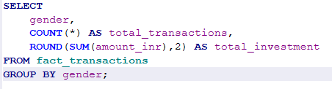
Output:
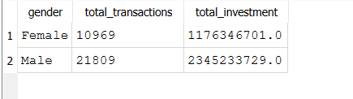

Key Insight
The analysis provides insights into investment behavior patterns among different gender groups.

Query 10: Best Risk-Adjusted Funds
Business Objective
Identify funds that effectively balance returns and risk using Sharpe Ratio and Sortino Ratio metrics.
SQL Query
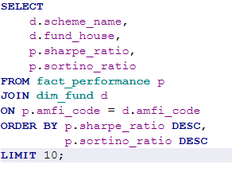
Output
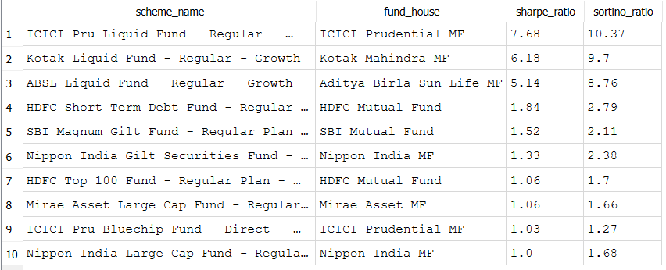

Key Insight
These funds demonstrate efficient risk management while maintaining competitive returns for investors.

Conclusion
This SQL analysis successfully transformed raw mutual fund datasets into meaningful business insights using relational database techniques and analytical SQL queries.
The analysis enabled:
- Identification of top-performing funds based on returns and ratings.
- Evaluation of fund size through Assets Under Management (AUM).
- Assessment of risk-adjusted performance using Sharpe and Sortino Ratios.
- Analysis of SIP growth trends and investor participation.
- Understanding of demographic investment patterns.
- Examination of regional investment activity across states.
The database architecture, data cleaning process, and analytical SQL framework developed in this project provide a strong foundation for future business intelligence dashboards, performance scorecards, and investment recommendation systems.

